SURGE PROJECT

Name: Aravind Seshadri

Roll No: 210180

Assignment 1B: Interfacing MATLAB with VREP/COPPELIASIM

To establish a connection between MATLAB and V-REP, we must execute the function simExtRemoteApiStart(19999), where 19999 is the socket port number.

1. Step 1: Setting up the V-REP environment

We first set up the V-REP environment to establish a connection between MATLAB and VREP and run a basic program. From the model browser, under robots/mobile, we add Pioneer P3DX. We also add a cuboid object that acts as an obstacle.

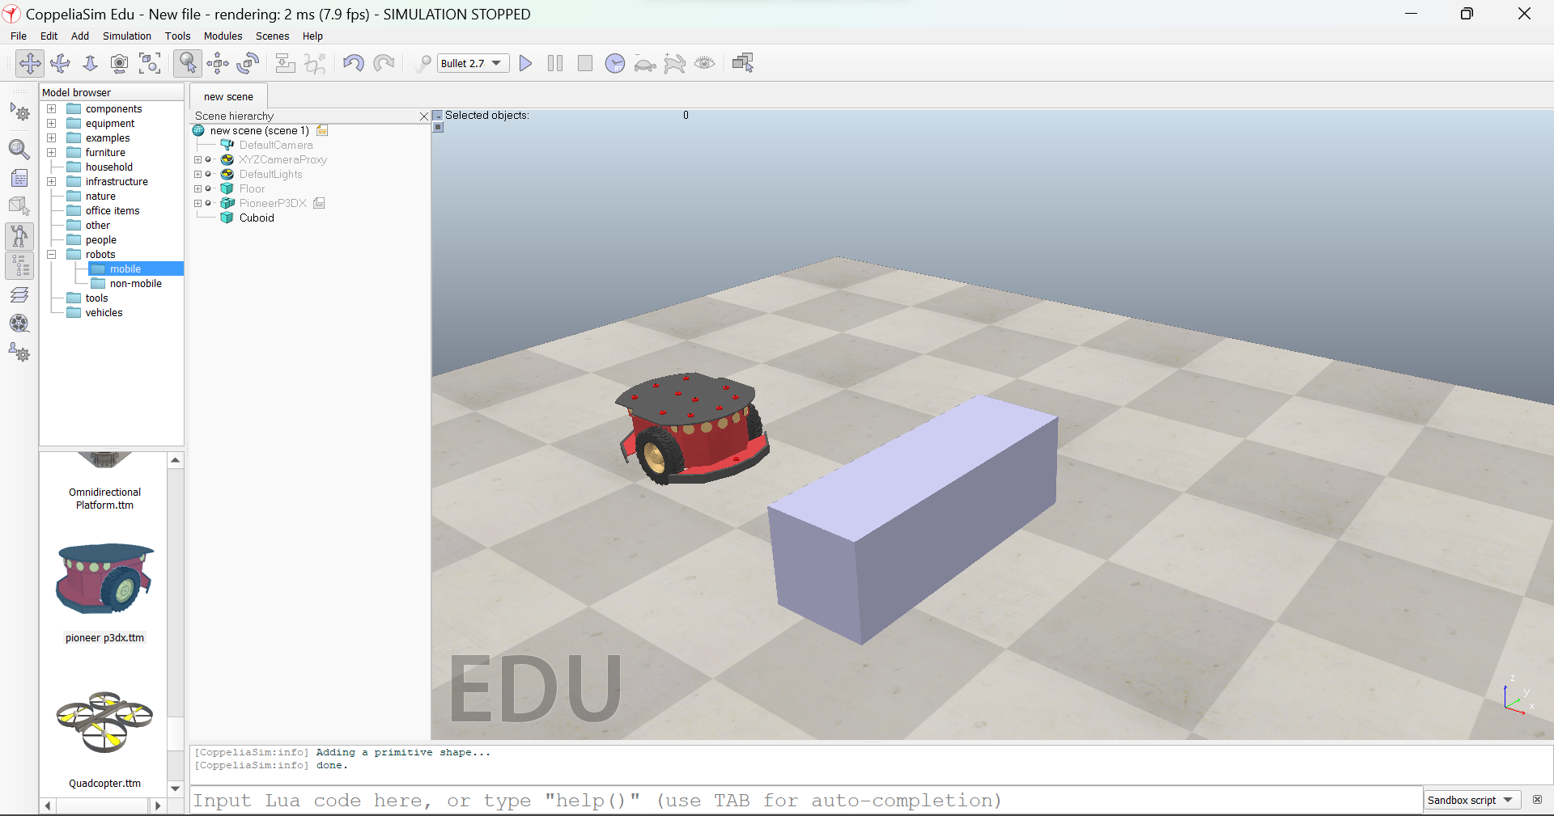

1. Step 2: Executing function on VREP

We add the previously mentioned function simExtRemoteApiStart(19999) to a non-threaded Associated Child Script on the cuboid. It can also be added to the sandbox script at the bottom of VREP.

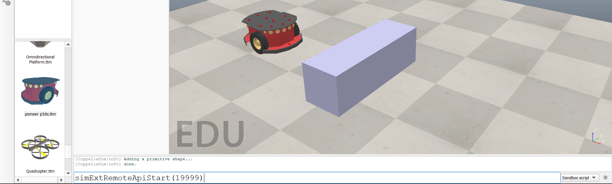

1. Step 3: Creating the Workspace

Create a new folder and save the scene as ‘matlab-vrep’ in the folder. Next, we must copy some files from the V-REP installation directory to our workspace. Go to the path “C:\Program Files\CoppeliaRobotics\CoppeliaSimEdu\programming\legacyRemoteApi\remoteApiBindings\matlab\matlab.” From here, the files remApi,remoteApiProto, and simpleTest are copied and pasted into the workspace. Also, copy the “remoteApi.dll” file from the lib directory in “remoteApiBindings.”

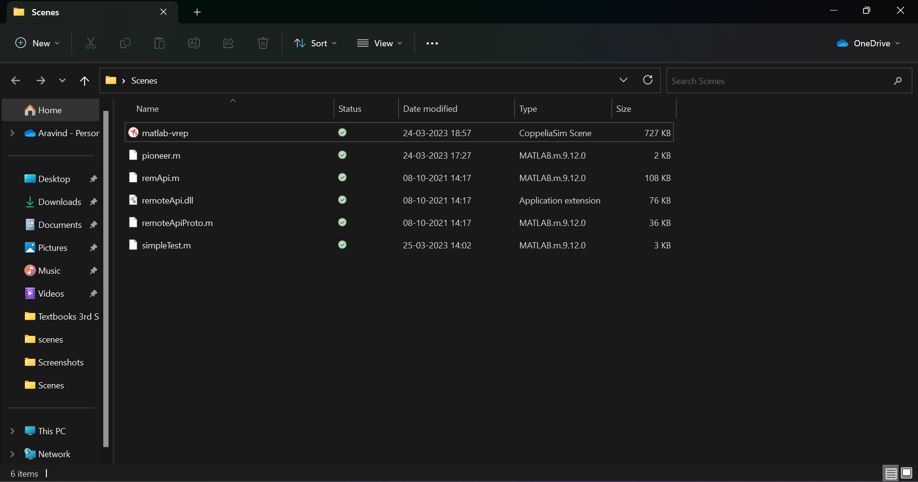

1. Step 4: Establishing connection on MATLAB for a demo code

Open the workspace created on MATLAB. Open the simpleTest.m code on Matlab. We first run the simulation on V-rep and then run the code on MATLAB. We would observe the output of the number of objects on the screen and the mouse pointer's position on VREP. This implies that the connection was successful.

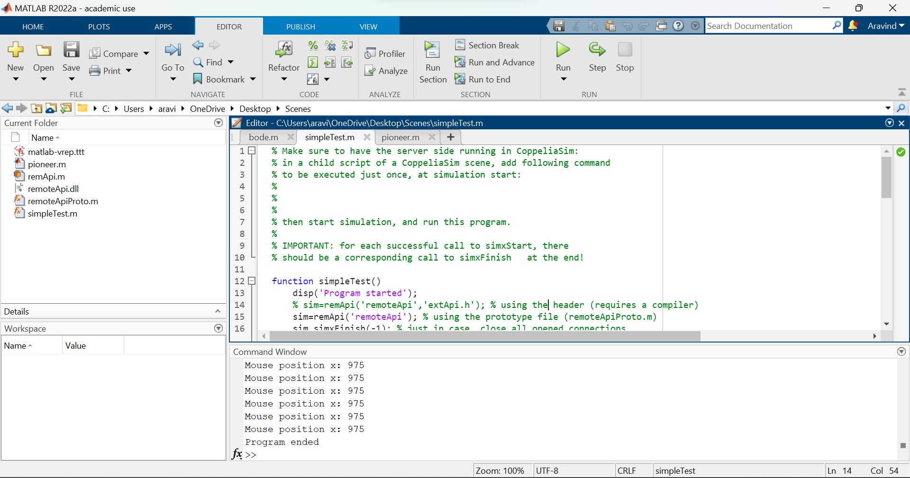

A basic program is run to understand the API commands.

1. Step 5: Disabling pioneer script

We disable the pioneer script to control the actuators’ motion.

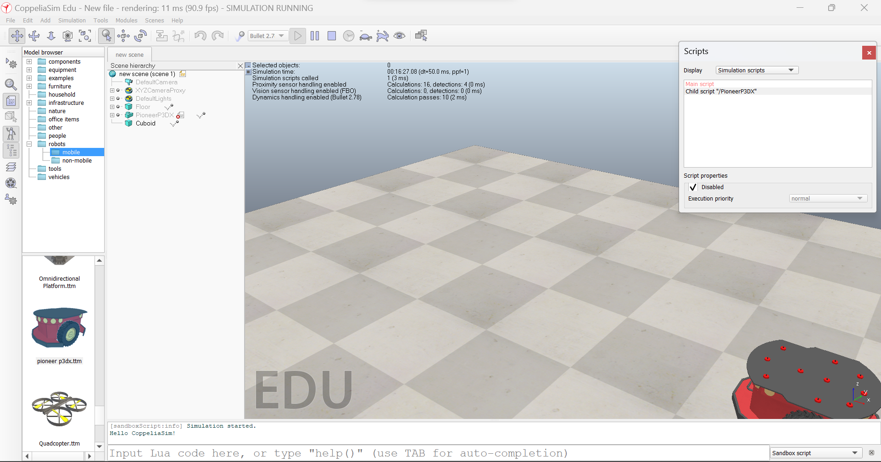

1. Step 6: Typing and understanding the code on MATLAB:

The following code is written on a new file in the same workspace. This is done to establish the connection.

sim=remApi('remoteApi'); ##This is the remoteAPI object created

sim.simxFinish(-1); ## This kills all existing connections

clientID=sim.simxStart('127.0.0.1',19999,true,true,5000,5);

##This object establishes a connection to the corresponding IP and port number

if(clientID>-1)

disp('Connected')

sim.simxFinish(-1);

end

sim.delete()

1. Step 7: Further additions to the code to cause the robot wheel to spin

The following code causes the left wheel of the bot to rotate.

sim=remApi('remoteApi');

sim.simxFinish(-1);

clientID=sim.simxStart('127.0.0.1',19999,true,true,5000,5);

if(clientID>-1)

disp('Connected')

[returnCode,left_motor]=sim.simxGetObjectHandle(clientID,'/PioneerP3DX/leftMotor',sim.simx_opmode_blocking); ## returns the object handle of the left motor. If the returnCode=0 then the function has executed correctly

[returnCode]=sim.simxSetJointTargetVelocity(clientID,left_motor,0.5,sim.simx_opmode_blocking); ## sets the velocity of the left motor as 0.5

pause(5) ##waits for 5 secs

[returnCode]=sim.simxSetJointTargetVelocity(clientID,left_motor,0,sim.simx_opmode_blocking); ##Sets the velocity as zero

sim.simxFinish(-1);

end

sim.delete()

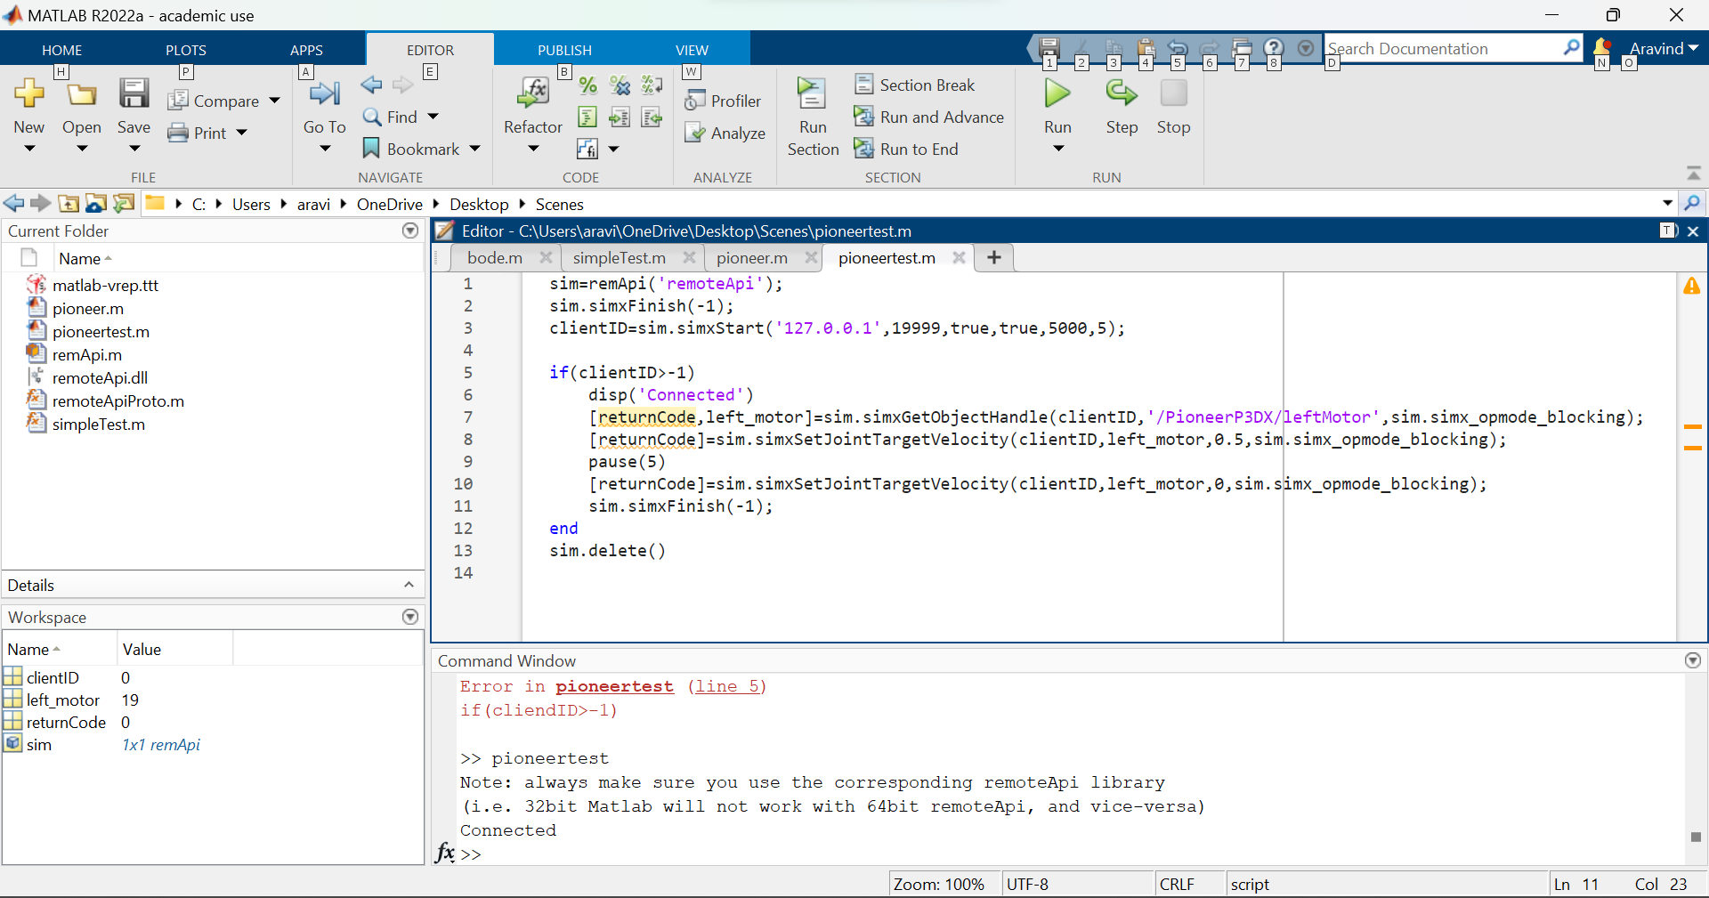

1. After running both programs, the bot rotates at a rate of 0.5 for 5 seconds, and then the program stops.

